Department: Music Course: 9-12 Band 2016-2017

Fall Concert Pieces:
Fanfare for the Third Planet- Richard Saucedo

Washington Post March- Sousa
In Paths of Truth and Grace- Randall Standridge
Sparks- Brian Balmages
Christmas Pieces:
Whisper To Their Souls- Hazo
Minor Alterations- Lovrien
Christmas Festival- Leroy Anderson
Carmen Christmas- Randall Standridge
Spring Pieces:
Noah’s Ark- Navarro
American Riversongs- LaPlante
October- Whitacre
Havendance- Holsinger

Term, Phrase, or Expression | Simple Definition | Comprehension Support
Articulations | The symbols that show the way a note is played with either a hard or soft start | 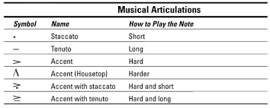
Dynamics | The volume at which the notes are played, whether loud or soft | 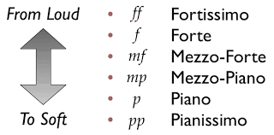
Style | A specific way of playing the notes which follows the history or background of the specific area or group it came from. May alter the way the written note is played | BeBop:  https://www.youtube.com/watch?v=NcTrx0hL1ag  Swing:  https://www.youtube.com/watch?v=OlBQIb-sODA  Funk: https://www.youtube.com/watch?v=UvzxYEW6dRI

Scales | Collections of notes in a specific pattern beginning on a specific pitch, used to create a center of pitch for the listener | 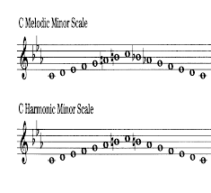
Key Signature | The designation of which scale, or collection of notes, a piece is played in. Shows which notes to raise or lower by a half step | 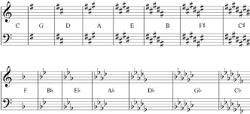
Circle of Fifths | The relationships of scales to one another based on amount of accidentals | 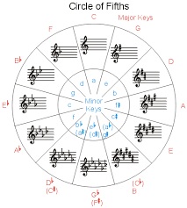
Accidentals | Symbols that tell us to either raise or lower a note | 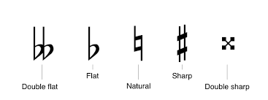

Tune | The process of checking our instrument’s frequency at which it creates sound. | https://www.youtube.com/watch?v=EdOYGHXkW_g
March | A piece of music with a strong and repeated rhythm made for people to walk in time to. Typically follows an ABA format | Washington Post March above
Fingerings | The button or combination of buttons or keys you press to produce a sound | http://daviehighbands.weebly.com/fingering-charts.html
Tempo/ Transitional Tempos | A specific number of beats each minute, or general estimate of speed describing how fast or slow a piece should be played./ Terms that show how to change between two tempos | 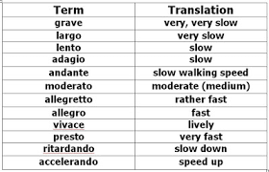

Warm-up | The process of conditioning your face or body to become prepared to operate your instrument before playing intensely. | http://www.taylor.kyschools.us/userfiles/1180/Classes/8223/Mello.pdf
Percussion | The section of the band that creates sound on their instrument through striking the instrument. | 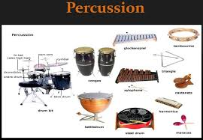
Brass | The section of the band that produces sounds through buzzing of the lips on a mouthpiece | 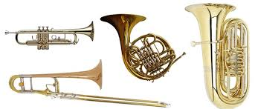
Woodwinds | The section of the band that produces sound by blowing air across an opening or reed, but not buzzing the lips. | 