Department: Science Course: Biology 2016-2017

Term, Phrase, or Expression | Simple Definition | Comprehension Support
Unit 1: The Science of Biology
biology | The study of living things | http://wordpress.ed.pacificu.edu/elisabethhalemeier/files/2012/09/Screen-shot-2012-09-04-at-5.25.30-PM.png
investigate | To examine, ask questions about, or find solutions to a problem or question. | http://scienceinvestigators.wikispaces.com/file/view/scientif_method_OK.png/442326542/scientif_method_OK.png
observation | The process of examining something or someone carefully or in order to gain information about it. | http://scienceinvestigators.wikispaces.com/file/view/scientif_method_OK.png/442326542/scientif_method_OK.png
data | Facts/statistics collected together to analyze, often as the results of an experiment.
analyze (analysis) | To examine something (often data or the results of an experiment) in detail in order to explain or interpret the meaning of the results | http://scienceinvestigators.wikispaces.com/file/view/scientif_method_OK.png/442326542/scientif_method_OK.png
hypothesis | A testable statement which explains how or why something occurs | http://scienceinvestigators.wikispaces.com/file/view/scientif_method_OK.png/442326542/scientif_method_OK.png
controlled experiment | A scientific procedure done in order to test a hypothesis | http://scienceinvestigators.wikispaces.com/file/view/scientif_method_OK.png/442326542/scientif_method_OK.png
variable | Any factor that changes in an experiment | 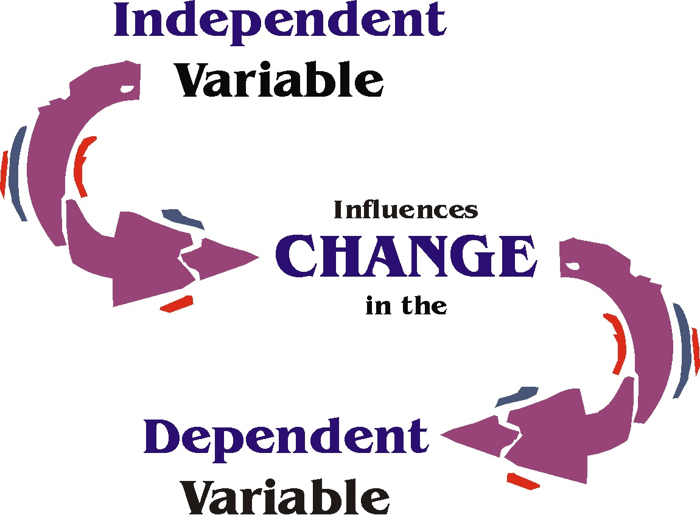
independent variable | A type of experimental variable which is purposely changed by the person conducting the experiment
dependent variable | A type of experimental variable which is the response to the change- this is measured by the person conducting the experiment
theory | a well-tested explanation supported by a broad range of observations (a lot of experimental evidence)
constants | factors in an experiment which remains the same throughout the experiment | https://www.youtube.com/watch?v=tK2mBsSb3uw
control group | the group in an experiment which does not receive the independent variable | https://www.youtube.com/watch?v=tK2mBsSb3uw
experimental group (test group) | the group in an experiment that receives the independent variable being tested | https://www.youtube.com/watch?v=tK2mBsSb3uw
repeated trials | Doing an experimental test more than once (the more repeated trials there are, the more tests an experimenter does) | https://www.youtube.com/watch?v=tK2mBsSb3uw
organism | A living thing (animal, plant, bacteria, protist, fungus) | http://www.differencebetween.info/sites/default/files/images/2/living-and-nonliving.jpg
cell | The smallest, most basic unit that can be considered alive (the smallest, simplest living thing) | 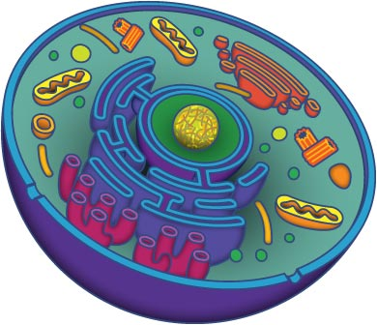
grow | To change, usually in a way to become larger/stronger
develop | To change, usually in a way that allows you to become more capable or able to do something you couldn’t before.
homeostasis | The process of maintaining an internal stable environment (in your cells and, as a result, in your entire body) | https://www.youtube.com/watch?v=-W7kAyUQT0E
sexual reproduction | Reproduction in which cells from two different parents unite to form the first cell of a new organism (done by most animals and plants, some fungi) | http://patreview9.weebly.com/uploads/3/0/5/0/30504002/8259233.png?437
asexual reproduction | Reproduction in which one parent produces offspring (babies) identical to itself (done by bacteria and some fungi, animals, plants) | http://patreview9.weebly.com/uploads/3/0/5/0/30504002/8259233.png?437
metabolism | A combination of chemical reactions inside an organism’s body through which an organism builds up or breaks down materials in order to obtain energy and nutrients (structural materials)- fueled by eating and breathing | https://s-media-cache-ak0.pinimg.com/originals/7a/63/a5/7a63a5b7613b3d5af41d257a7e215a8d.jpg
stimulus | Any change in an organism’s environment | http://image.slidesharecdn.com/characteristicsoflivingthings-130412055926-phpapp02/95/characteristics-of-living-things-4-638.jpg?cb=1365748179
respond | To detect and react to a stimulus | http://image.slidesharecdn.com/characteristicsoflivingthings-130412055926-phpapp02/95/characteristics-of-living-things-4-638.jpg?cb=1365748179
adapt | The adjustment or changes in behavior, physiology, and structure of an organism to become more suited to an environment.
compare | How are two (or more things similar to each other? | http://erinstraza.com/wp-content/uploads/2014/07/comparecontrast.jpg
contrast | How are two (or more) things different from each other? | http://erinstraza.com/wp-content/uploads/2014/07/comparecontrast.jpg

