Department: Social Studies Course: Economics 2016-2017

Term, Phrase, or Expression | Simple Definition | Comprehension Support
Circular Flow | The movement of resources and goods in a society | 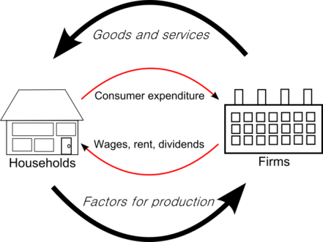
Competition | Several firms or individuals attempting to acquire the same item or goal.
Deflation | The general decrease in prices | 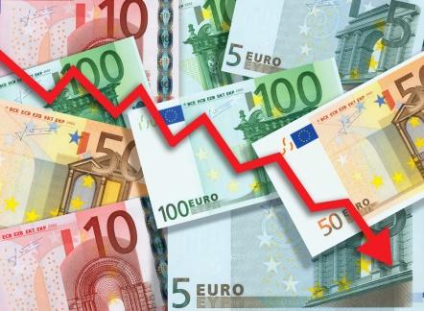
Elasticity | A measure of how much price changes when something else changes. | 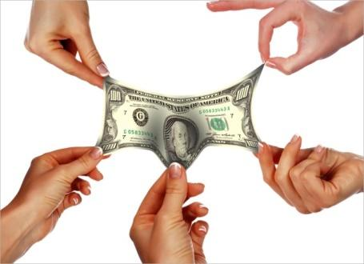
Equilibrium | A time when the supply of a product matches the demand for it. | 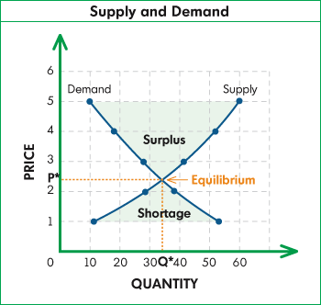
Externalities | Anything that affects the value or impact of an item or service
Firms | Organizations that make business decisions
GDP | The dollar value of all products created in a country | 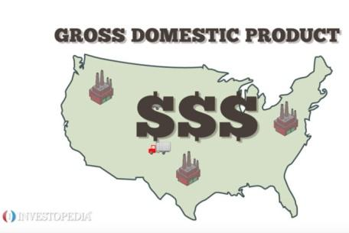
GNP | The dollar value of all products created by a country | 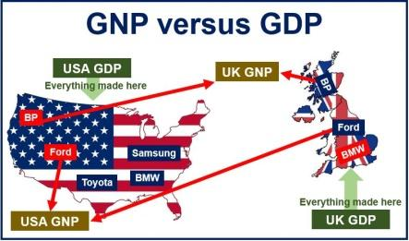
Inflation | The general increase in prices | 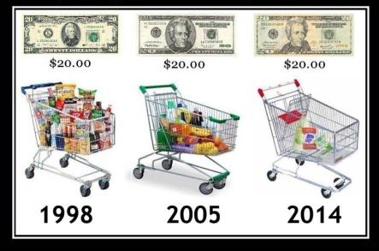
Law of Demand | As price falls, demand increases | 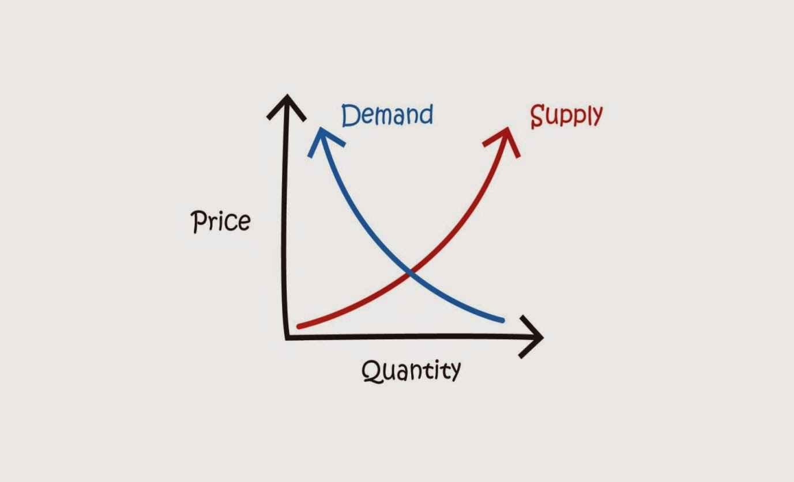
Law of Supply | As supply increases, prices fall
Macroeconomics | Economics of entire countries or the world | 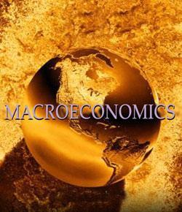
Microeconomics | Economics of specific firms or people | 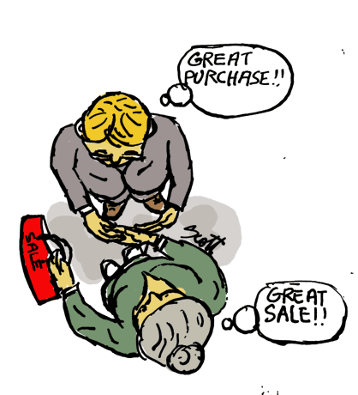
Market | A place where goods and services are exchanged for money | 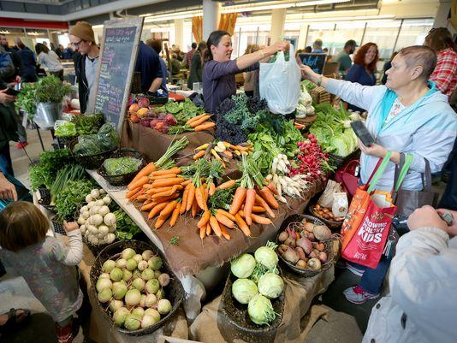
Monopoly | Complete control of a market | 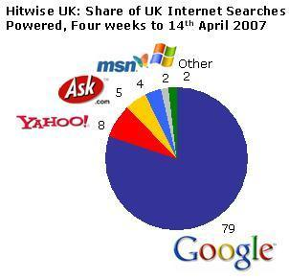
Needs | What an individual requires for survival | 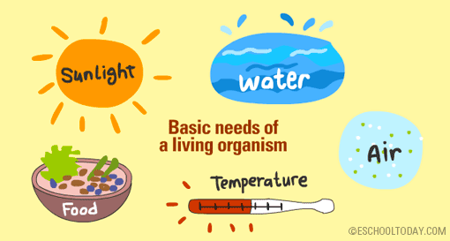
Opportunity Cost | The things given up when a decision is made | 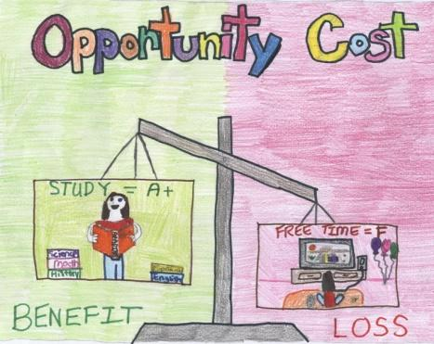
Price | The value paid for an item
Scarcity | There is not an unlimited supply of most products | 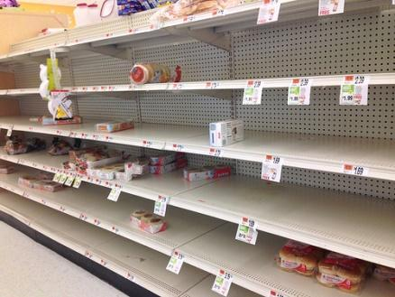
Wants | The desires of an individual | 