Department: Visual Arts Course: Intro to Art 2016-2017

Term, Phrase, or Expression | Simple Definition | Comprehension Support
Creative thinking | A way of looking at problems or situations from a new perspective | 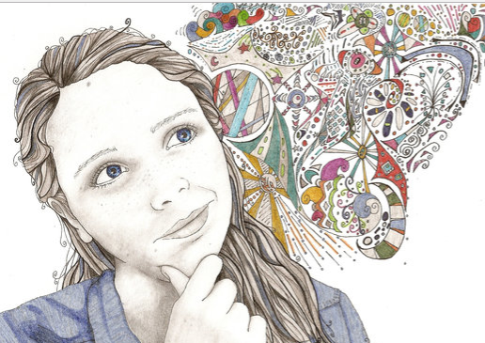
Generating new ideas | Creating an idea that has not been thought of before
collaboration | Working together with others
medium | Materials used to make art  medium video
Art elements | Visual parts of art | 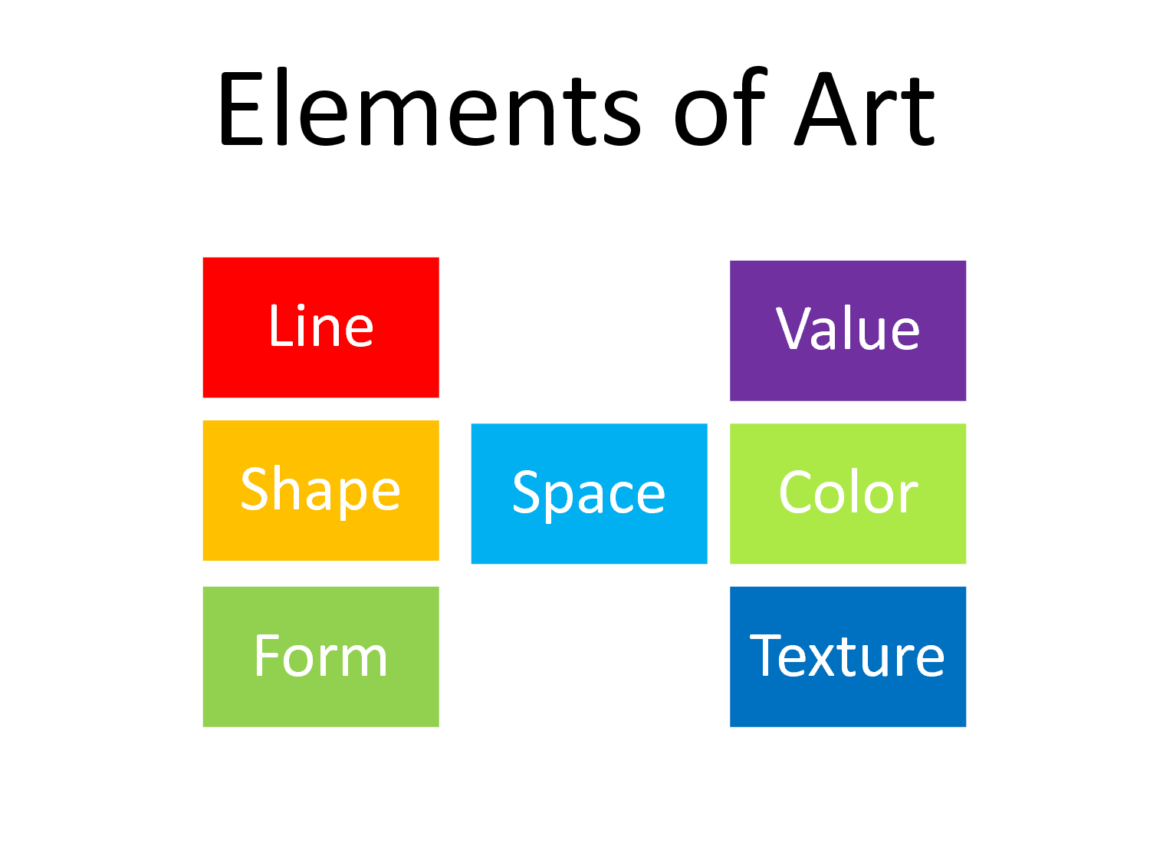
line | Continuous mark | line video
contour | A line that describes the shape of an object  contour video | 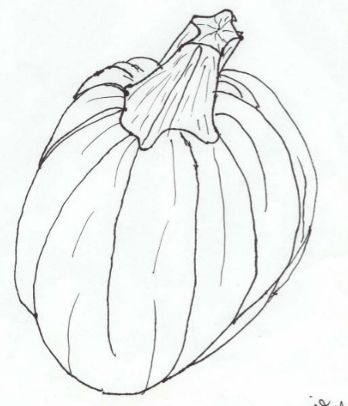
landscape | Represents natural scenery  landscape video | 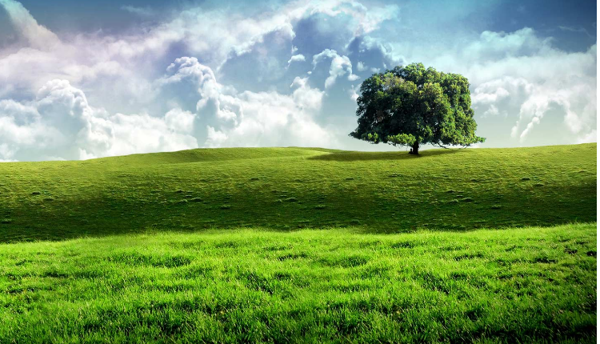
Horizon line | Where the land and the sky meet  horizon line video | 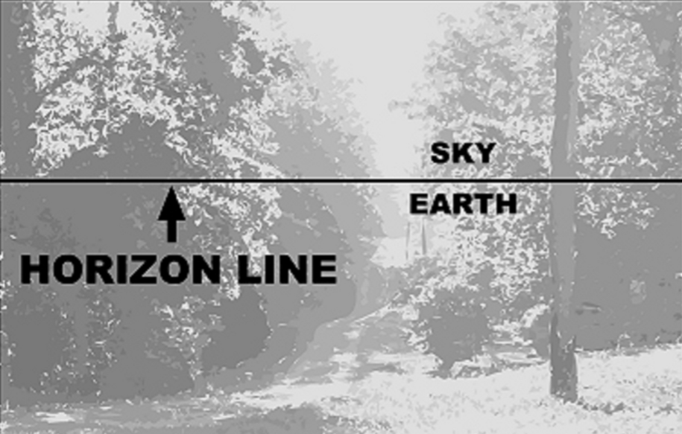
shape | A space enclosed by a line  shape video
color | Hue  color video | 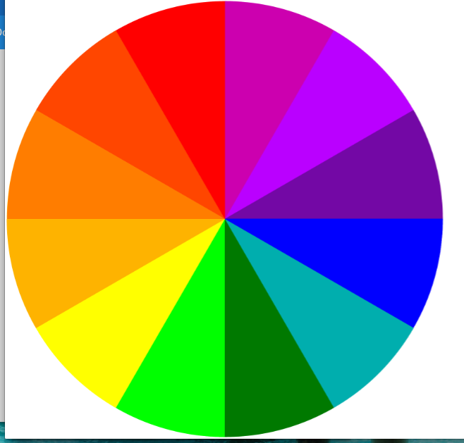
value | The range of lightness or darkness in a picture | value video
form | The shape of an object | form video
space | Area around an object, or the area inside an object | 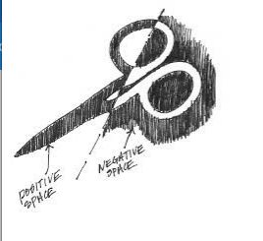
texture | The quality of the surface of an object | 