Department: Religion Course: Intro to Religion 2016-2017

Term, Phrase, or Expression | Simple Definition | Comprehension Support
Religion | a set of beliefs that help us answer life’s questions. | Video about the major religions of the world
believe | Something that is thought to be true, like an opinion. | Catholic beliefs are listed in the Nicene Creed
trust | belief in the reliability, truth, and strength of someone or something.  Christians have trust in God. | 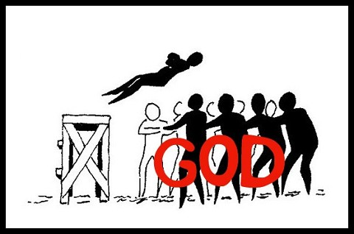  Video about Trust
faith | 1. to believe that God will care for us, love us and help us through life.  2. Believe in God without seeing God | 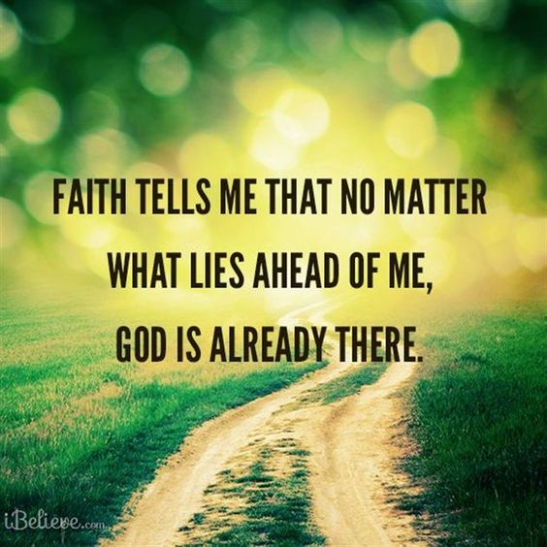
Holy Trinity | 3 persons in one God:  Father, Son and Holy Spirit | Video about Holy Trinity (watch from 0-50 seconds)
God the Father | God is a supreme being. God is the first person of the Holy Trinity. God is the Father of Jesus. God has many characteristics and names, found in the Bible. | Video about God
Holy Spirit | 3rd person of the Holy Trinity, Ru ah, breath of God | 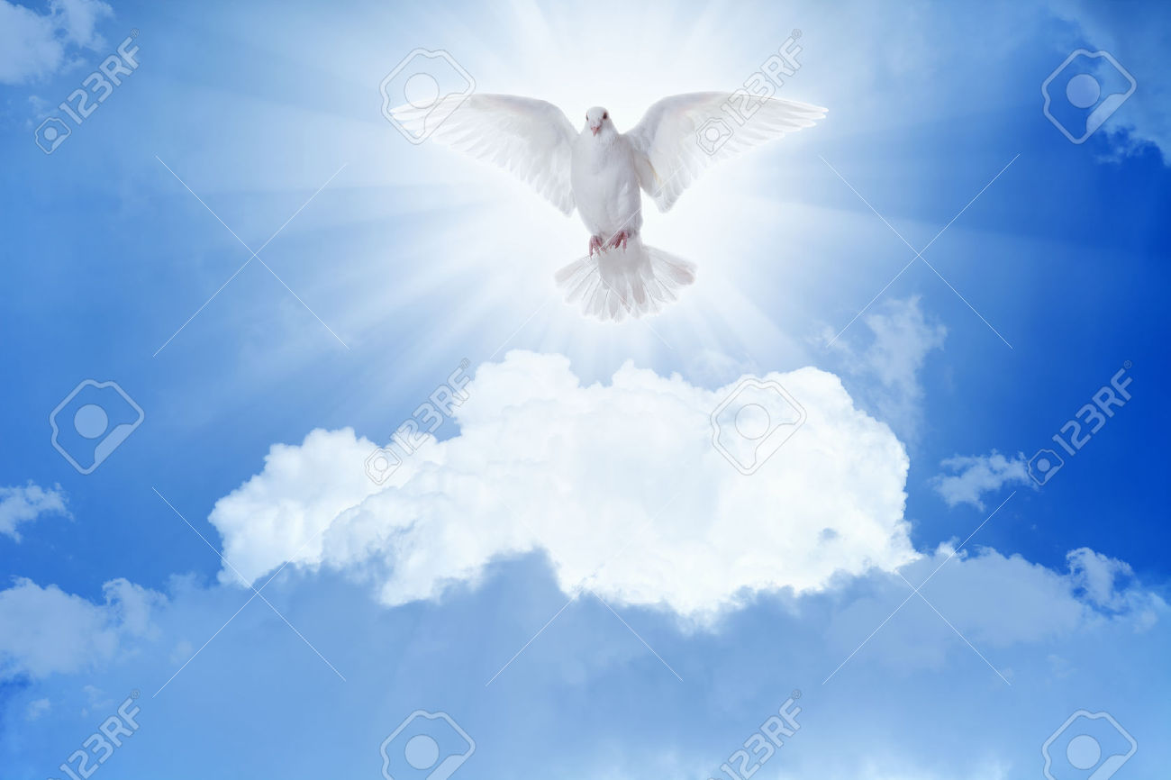
Jesus | 2nd person of the Holy Trinity. Jesus lived on earth over 2,000 years ago. He came into the world as a baby. Jesus began his public ministry at 30. He was crucified at 33. 3 days later he resurrected from the dead. He remained on earth for 40 more days and then ascended into Heaven. | 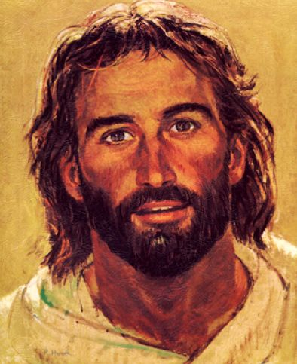
Jesus Christ | Jesus the Messiah is the Christ for those who are Christians | 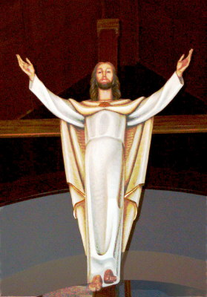
bible | Means “Holy Books”. It is a collection of sacred books for Christians. Contains different kinds of genres of writing. Christians believe all the people who wrote it were inspired by God. | 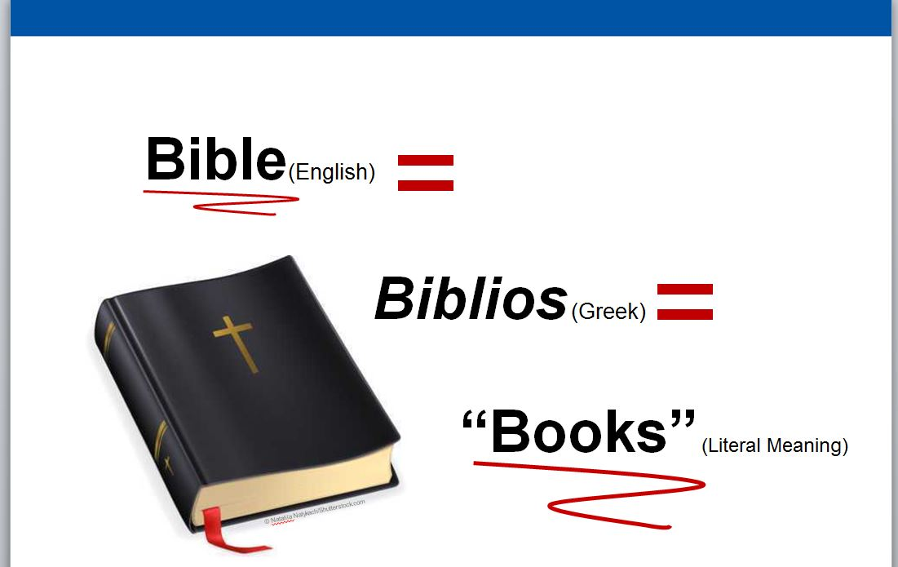
scriptures | Sacred readings from the Bible (is synonymous with the word “Bible) | 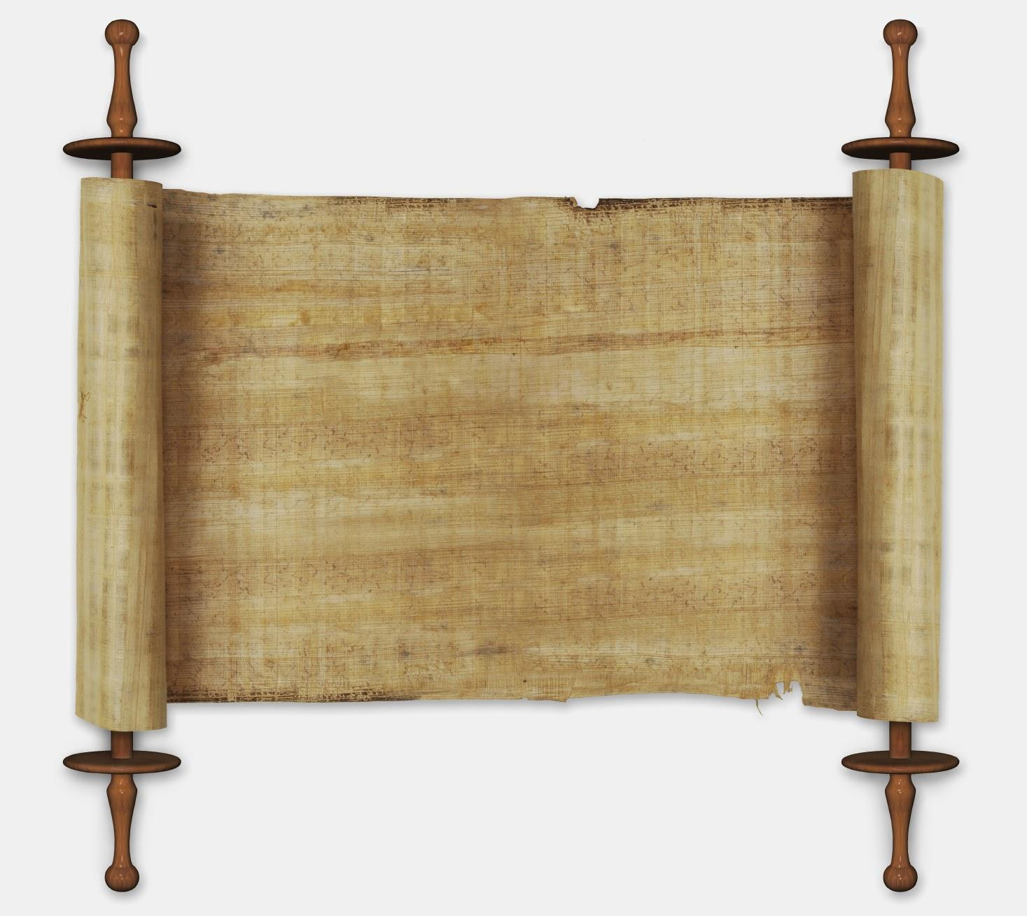
community | A community is a group of people who come together for a common purpose. | 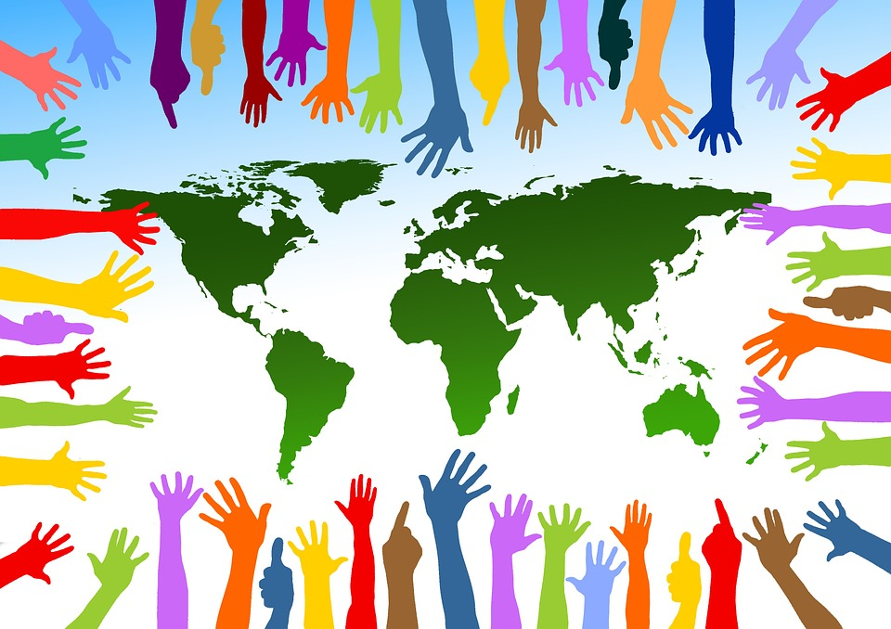
covenant | Promise, pact, agreement  *A covenant is a special promise made between people or between people and God. | 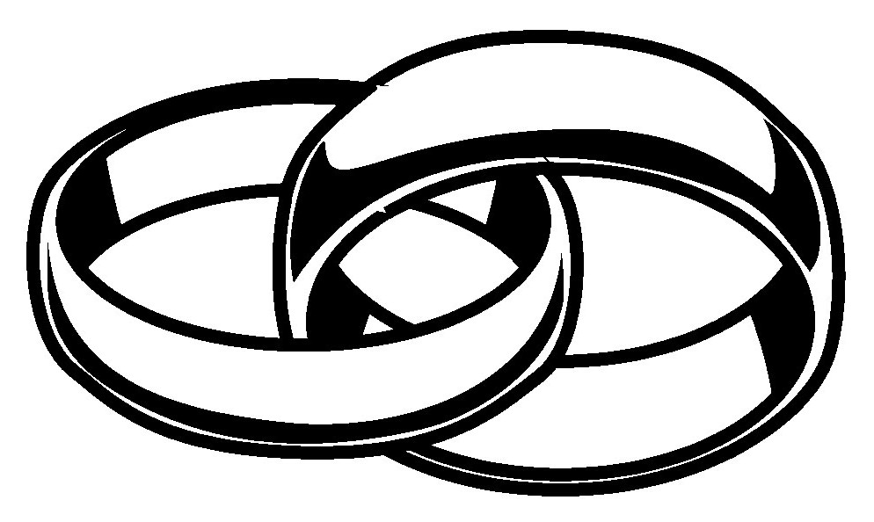
Catholic | There are several types of Christians. Catholic is one type of Christian, based in Rome, Italy.  Not all Christians are Catholic, but all Catholics are Christian. | 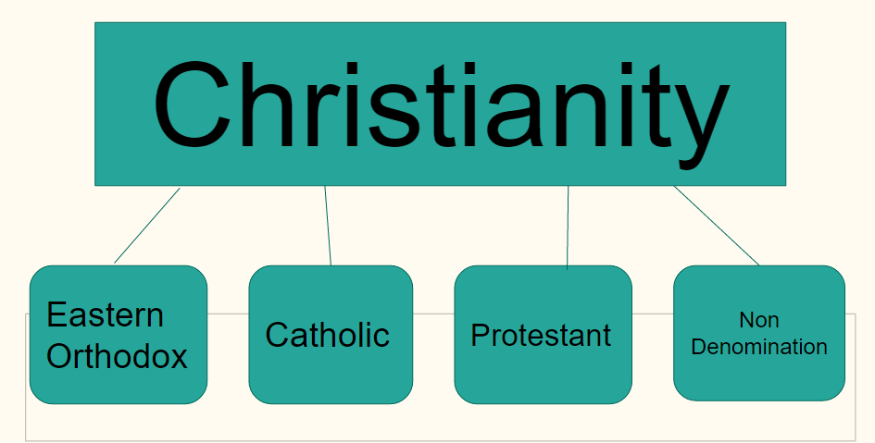
peace | - Calm, serene.  - The absence of violence | 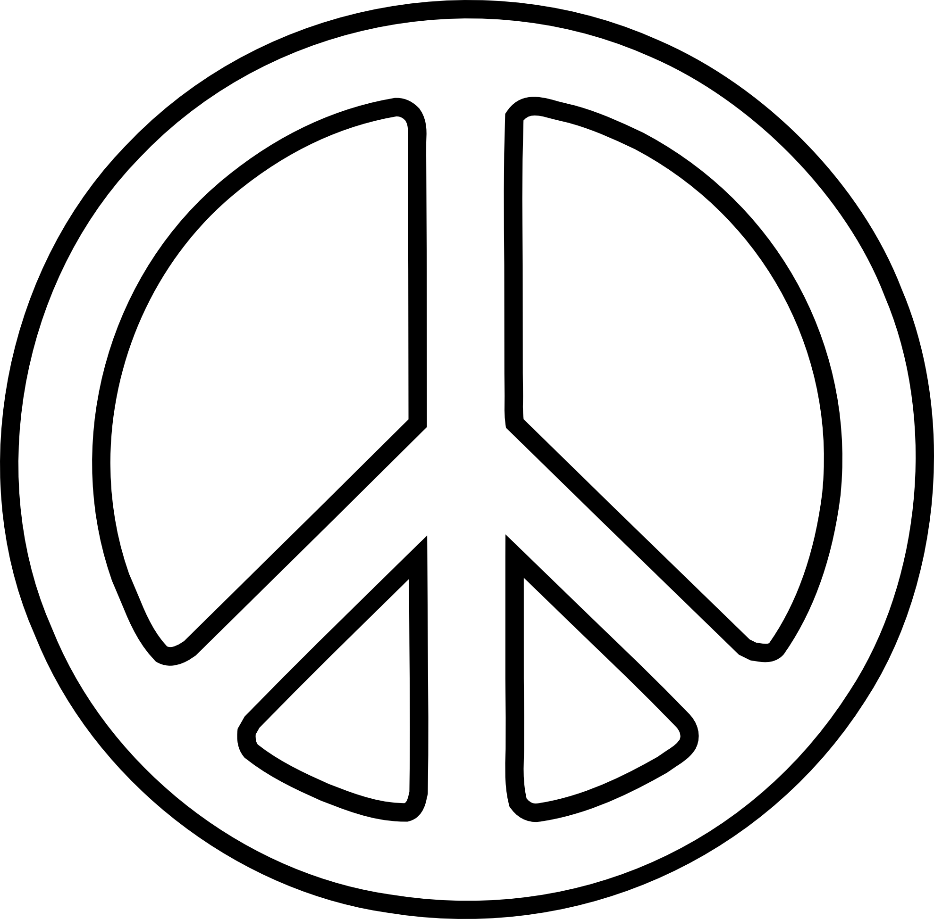
creed | Creed comes from the Latin root Credo, which means, “I believe.”  As Catholic Christians, the Nicene Creed states what we believe. | Video about Creed
sin | an action that hurts God, hurts others, and hurts you.  Example: telling a lie | 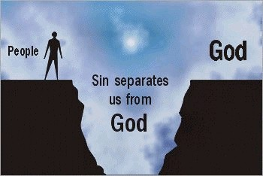
Circle of Grace | A safe zone surrounding people. This can be physically, mentally, emotionally, sexually.
Diocese | Area of parishes under a bishop | 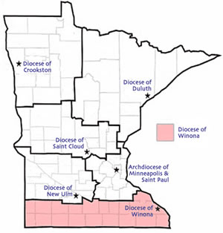
Chi Rho | The first 2 letters of Christ in Greek.
cross | Jesus died on a wooden cross. It is a symbolism of Christianity. It also represents the love God has for us, that he gave his only son to die for us. | 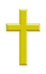
crucifix | The crucifix represents the death of Jesus Christ. Jesus was nailed to a cross and died on the cross.  This type of death is called “crucified.”  God loves us so much that he allowed his son, Jesus Christ, to die for us. | 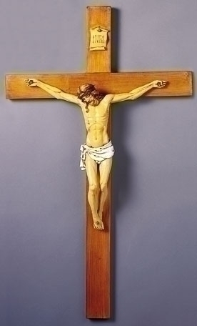
candle | It represents Jesus Christ among  us, reminding us that we are  always in the presence of God.
Mass | - Mass is the official religious service of the Roman Catholic Church  - Mass is the central act of prayer (anywhere you go is the world, Mass is the same).  - Mass remembers the last meal Jesus shared with his closest followers | 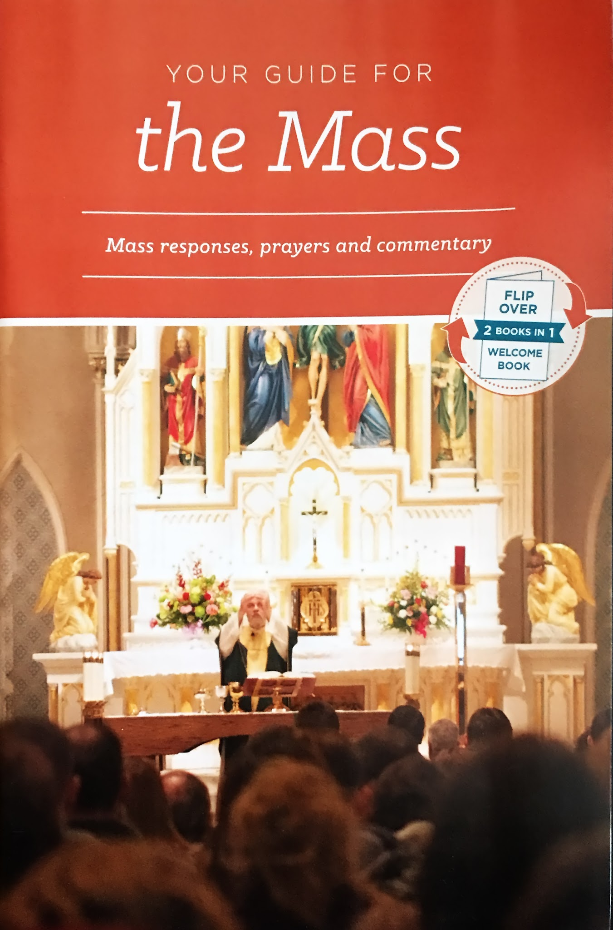
Body and Blood of Jesus | At every Catholic Mass we remember the Last Supper. The priest prays over bread and wine and they become the Body and Blood of Jesus. | 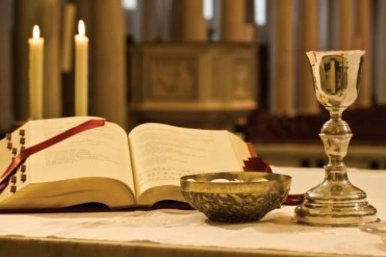
prayer | Communication with God. There are many ways to pray to God.
Community service | 1. Helping others without reward.  2. Using your talents to help people  or a cause without getting paid for your help. | 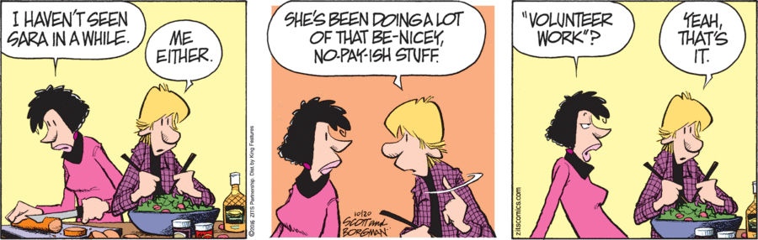
mercy | Forgiveness, Abundant love, compassion | 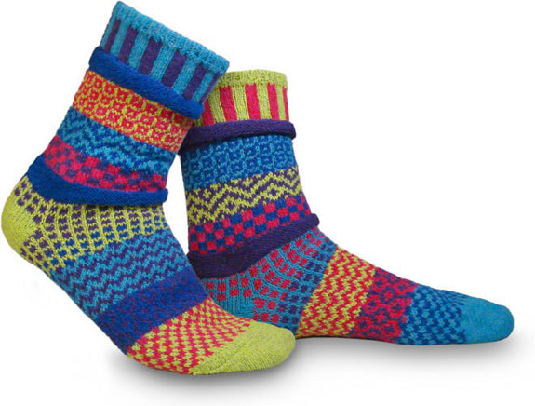
disciple | Follower (in Christianity, a follower of Jesus). | 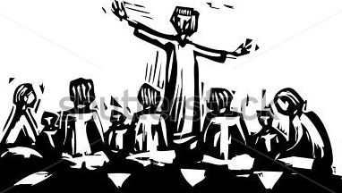
Last Supper | The night before Jesus died (sets up the Eucharist or Mass) | 