Department: Religion Course: Morality 2016-2017

Term, Phrase, or Expression | Simple Definition | Comprehension Support
Morality | The set of values that guide our choices | 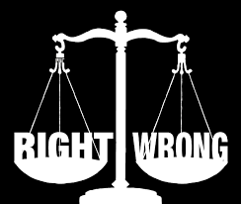
Habit | A regular pattern of actions | 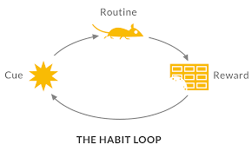
Vice | A bad habit or an inner desire to do something evil | 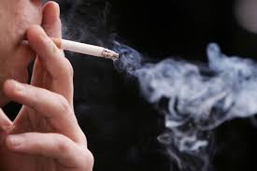
Virtue | A good habit or an inner desire to do something good | 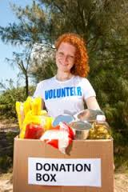
Cardinal Virtues | Virtues that are the foundation for all other virtues | 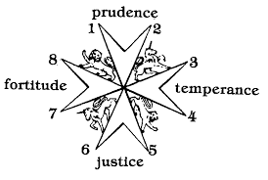
Theological Virtues | Virtues given to us by God that lead us back to God | 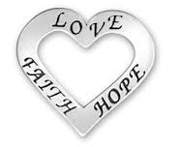
Moral Virtues | Virtues gained through our efforts to accept God’s gifts | Honesty, Respect for Persons, Compassion, Respect for Creation, Reverence for Human Life, Peacemaking
Freedom | The ability to freely choose, weigh, consider, and decide between options | 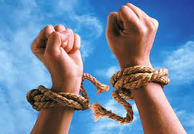
Power | The ability to act on freely chosen decisions affecting the world and ourselves
Knowledge | The information we have and the feelings we experience that helps us make decisions | 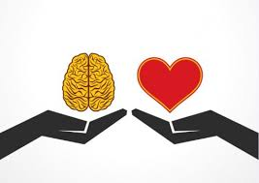
Responsibility | The ability to be accountable for our choices | 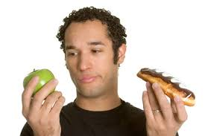
Christian view of the human person | Humans created in the image of God based on the creation stories in Genesis | 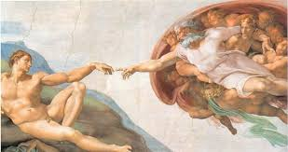
Sin | Being disconnected from God through a failure to love | 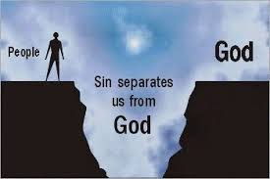
Conscience | The inner sense of right and wrong enabling individuals to discern moral choices freely | 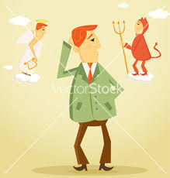
Conversion | A change of heart with the intention of following God more faithfully
Grace | God’s loving presence with us
Original SIn | Adam and Eve’s refusal to treat each other and themselves as being in the image of God | 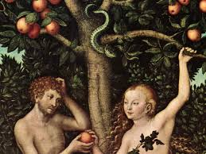
Guilt | A signal to us that we are uncomfortable with our own behaviour | 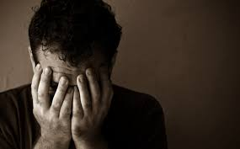
Shame | A message from others that we are not good or are worthless
Magisterium | The official teaching authority of the Catholic church | 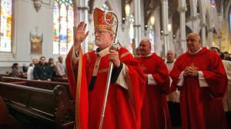
Image of God | God’s creation of human beings in God’s own image and likeness
Discipleship | Living a lifestyle modeled after the life of Jesus | 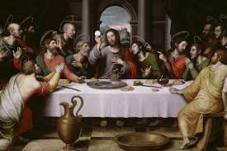
Authority | Someone/something that is reputable, respected, and obeyed | 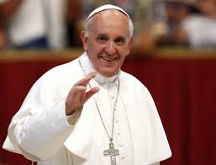
Values | a culture’s standard for discerning what is good and just in a society | 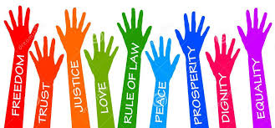
Beliefs | convictions that people hold to be true | 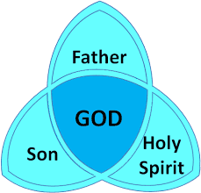
Stereotypes | preconceived ideas that attribute certain characteristics to all members of a class or set | 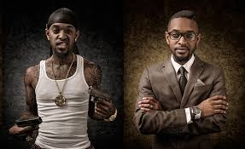
Bias | prejudice in favour of or against one thing, person, or group compared with another, usually in a way considered to be unfair | 