Vocabulary for Church (2nd semester, grade 10 religion)

Department: Religion Course: Religion 10 2016-2017

Term, Phrase, or Expression | Simple Definition | Comprehension Support
Christ | Anointed One, Messiah | Chi Rho (on all Cotter stuff)
Pentecost | Beginning of the Church when the Holy Spirit filled the apostles and Mary, Jesus’ mom | 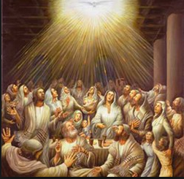
epistle | Greek for letter. Think of the New Testament letters. | 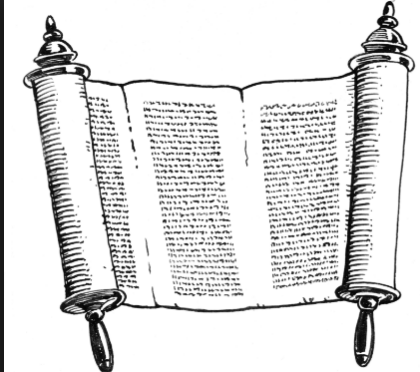
Eucharist | Also called the Mass or Lord’s Supper, and based on a word for “thanksgiving,” it is the central Christian liturgical celebration, established by Jesus at the Last Supper. | 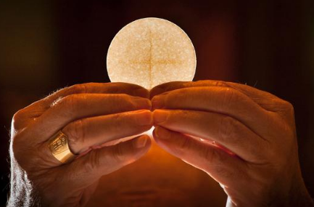
Domestic Church | Another name for the first and most fundamental community of faith: the family.
doctrine | An official, authoritative teaching of the Church based on the Revelation of God
dogma | a principle or set of principles laid down by an authority as incontrovertibly true.: "the Christian dogma of the Trinity" (online dictionary source) | 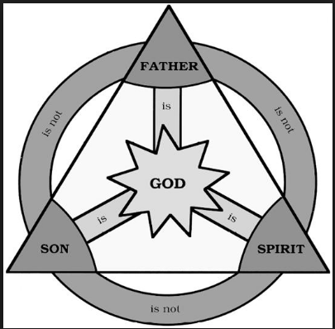
vocation | Teachings recognized as central to Church teaching, defined by the Magisterium and accorded the fullest weight and authority.A call from God to all members of the Church to embrace a life of holiness. Specifically, it refers to a call to live the holy life as an ordained minister, as a vowed religious (sister or brother), in a Christian marriage, or in single life. | 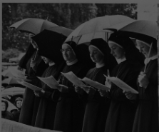  https://www.youtube.com/watch?v=ZGxWD9Yq73s on priesthood
Ecumenical Council | A gathering of the Church’s bishops from around the world convened by the Pope or approved by him to address pressing issues in the Church. | 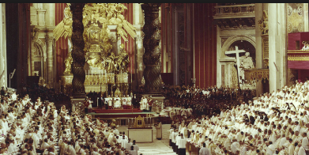
sacrament | An outward, visible sign of God’s grace. The Roman Catholic Church celebrates 7 of these | 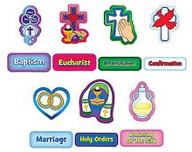
Holy Orders | The Sacrament by which members of the Church are ordained for permanent ministry in the Church as bishops, priests, or deacons | 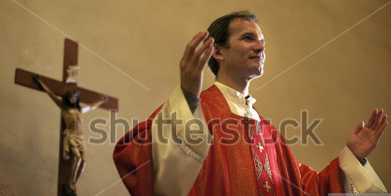
Marriage | Sacrament of life long commitment to married life
Confirmation | Sacrament of initiation (set up at Pentecost) | 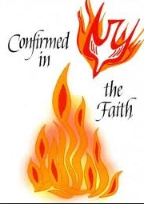
reconciliation | Sacrament of forgiveness of sin and

