Department: Social Studies Course: US History 2016-2017

Term, Phrase, or Expression | Simple Definition | Comprehension Support
amendment | Change or addition to laws of a country
battle | One fight between 2 armies in a war | 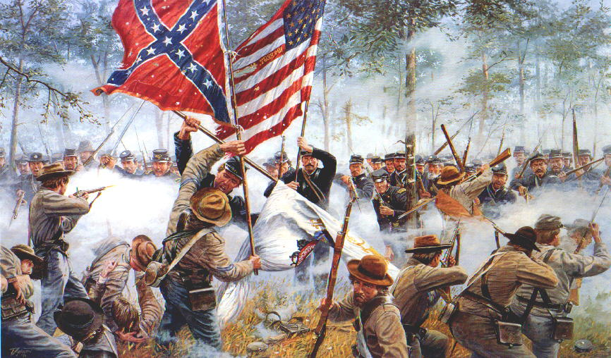
civil war | War between people of the same country | 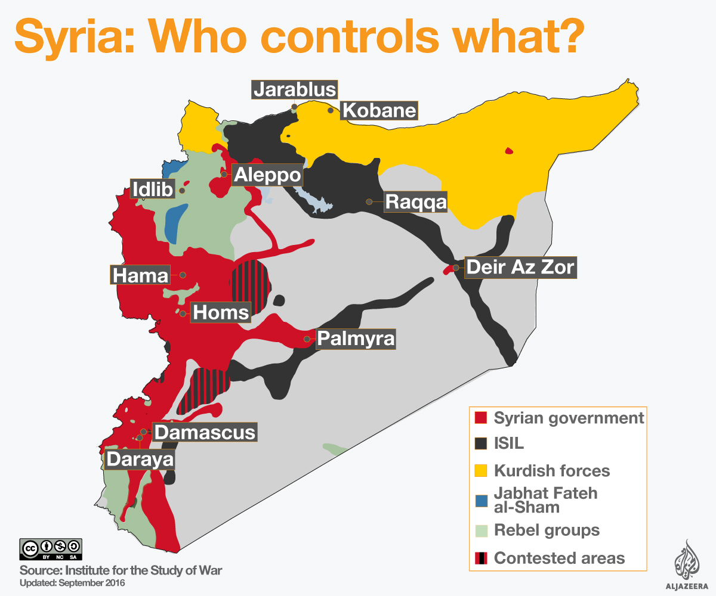  There is currently a civil war in Syria.
constitution | Document that describes the basic laws and organization of a government | 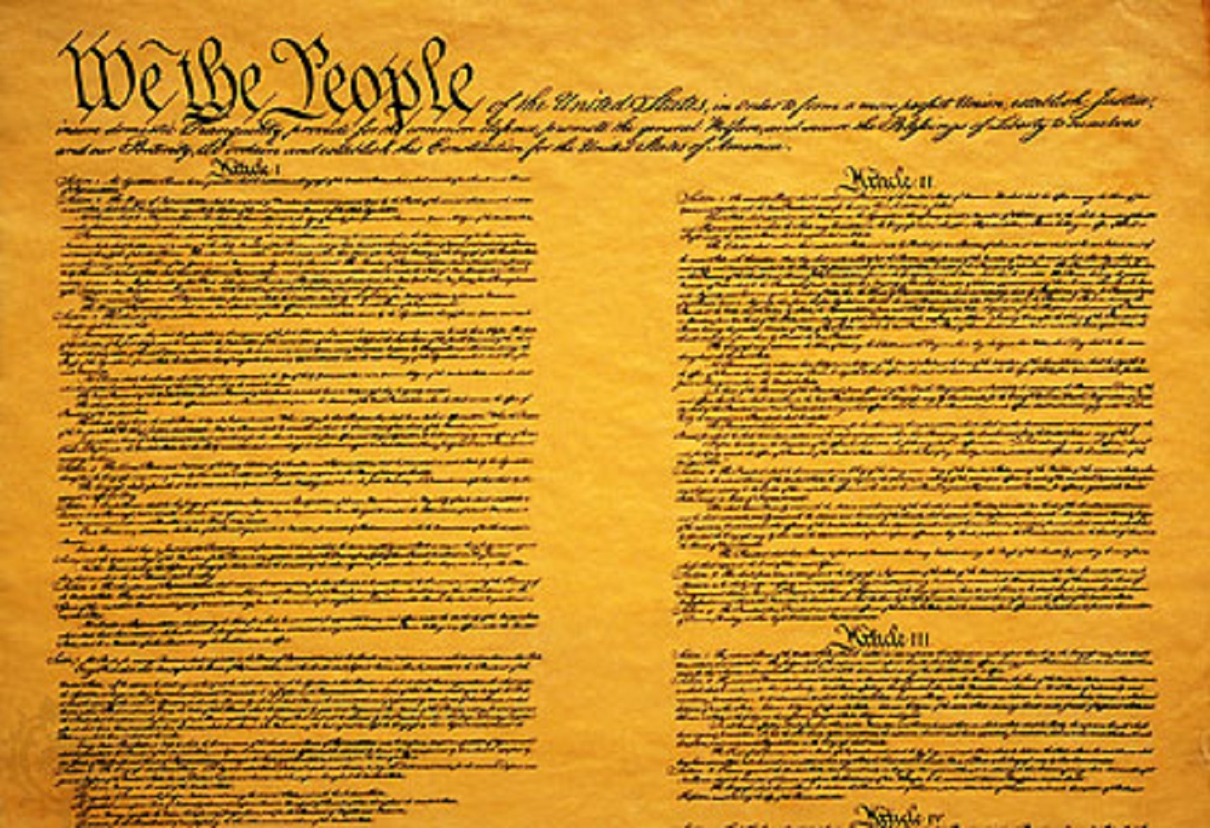
dictatorship | Government where the leader has full control and the people have few rights | 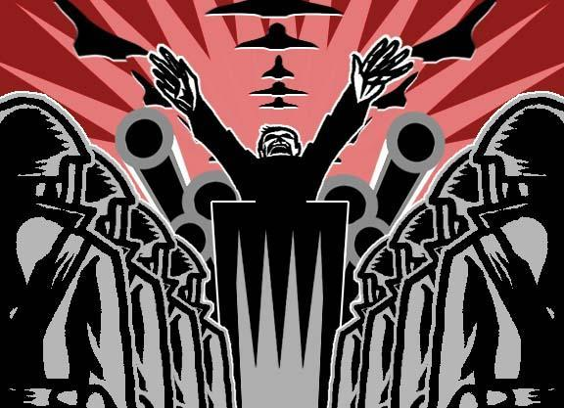
freedom | Being able to choose for yourself
government | Organization of a country under laws and groups of leaders
industry | Use of factories to make a lot of products using many workers
law | A rule or order that you must obey. If you break a law, you can go to jail. | 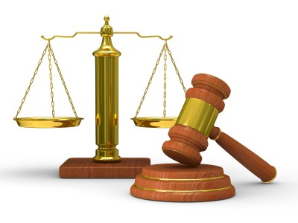
legislature | Part of government that makes laws, sometimes called Congress or Parliament | 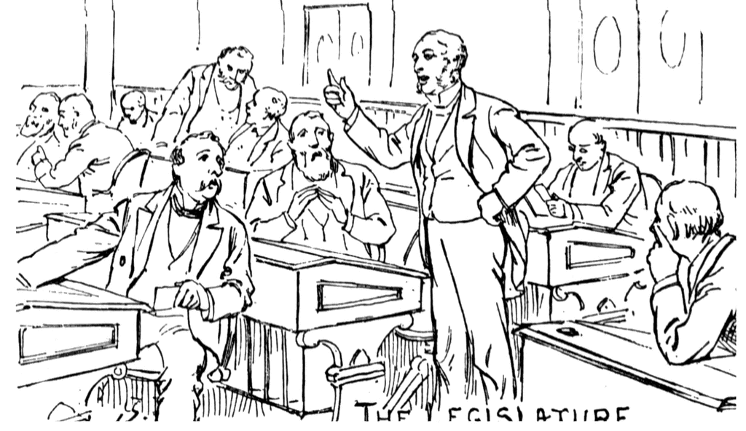
plantation | Large farm that grows one crop, often had slaves | 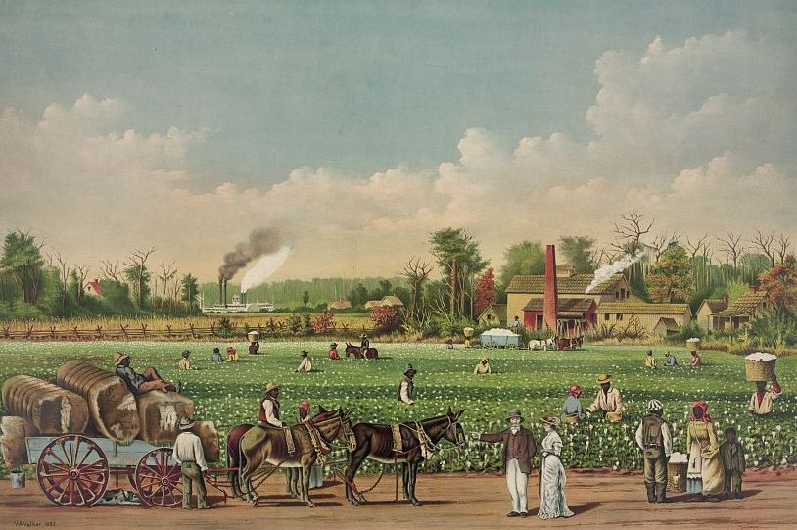
protest | A public complaint against an idea or event | 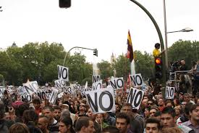
republic | Government where citizens vote for the leaders
revolution | a sudden change in government, where the old form of government is replaced with an entirely new type of government | 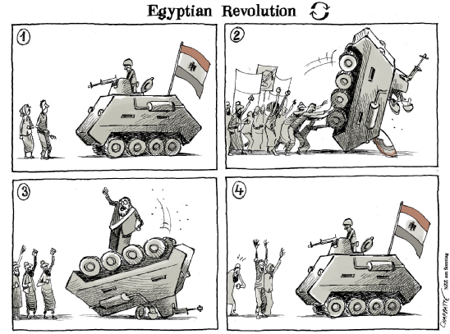
rights | what the people in a country are allowed to do | 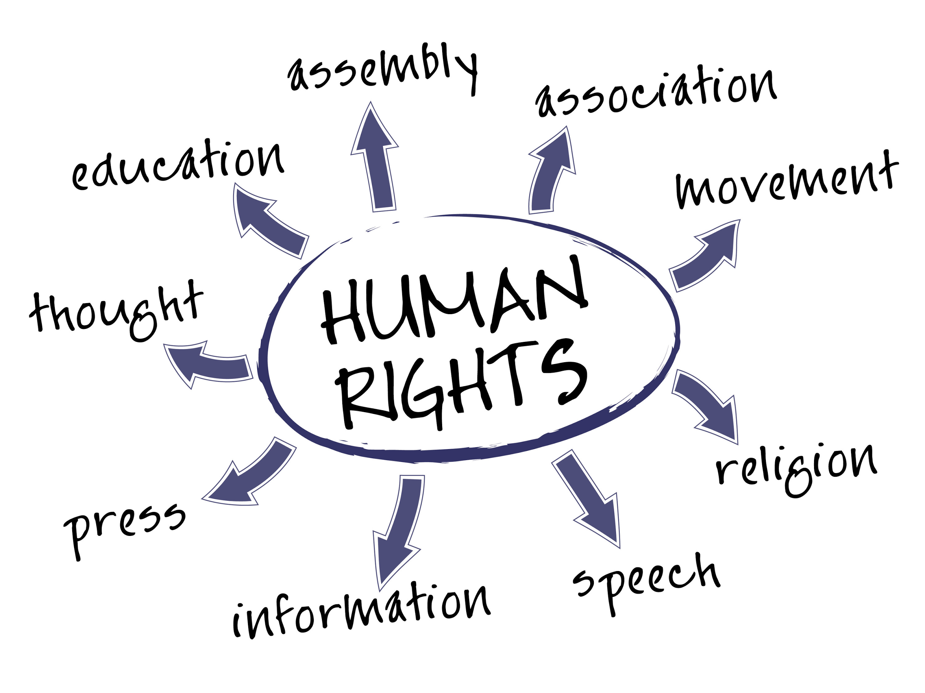
slavery | people are owned for life and forced to work without pay | 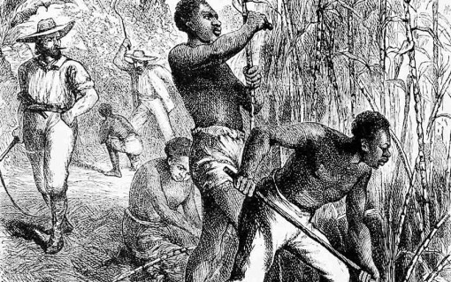
state | An area of the country with its own laws. The US has 50 states | 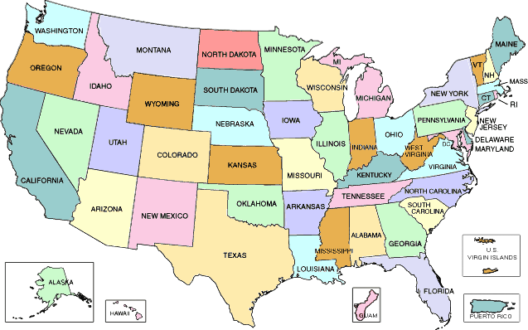
strategy | a careful plan or method to do something
suffrage | the right to vote | 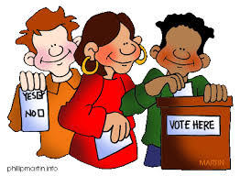
war | fight between 2 or more armies, for example: World War I, World War II, Korean War, Vietnam War

