Department: Social Studies Course: Human Geography 2016-2017

Term, Phrase, or Expression | Simple Definition | Comprehension Support
Agriculture | Growing plants and raising animals for the purpose of creating food. | 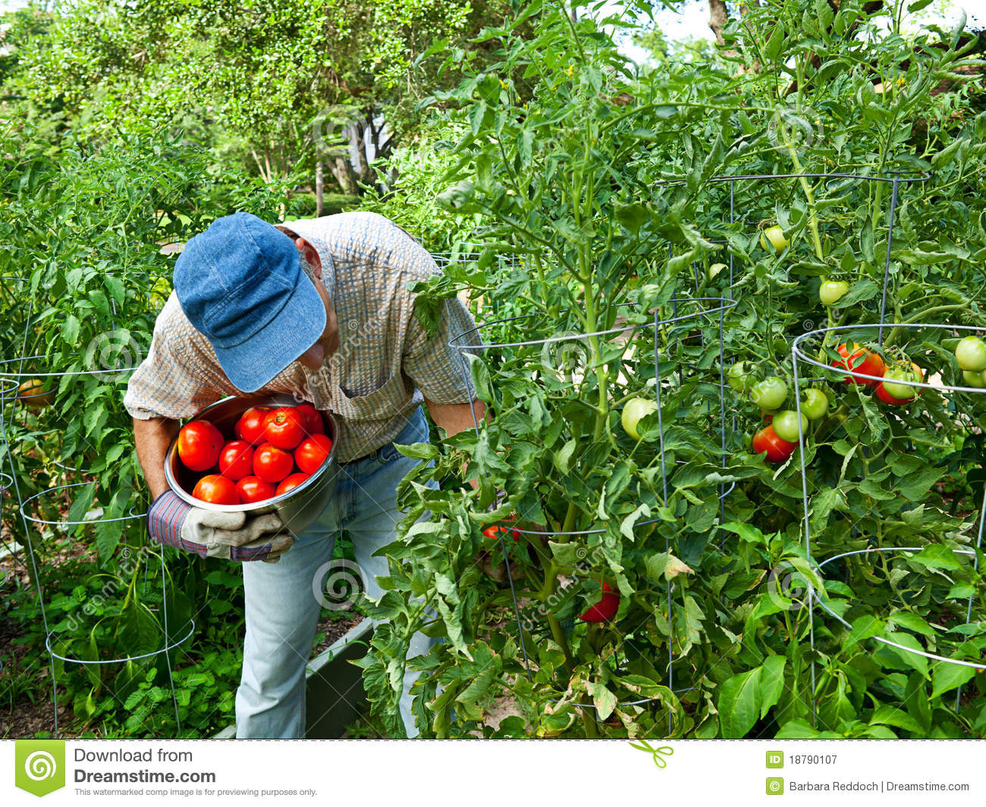
Nationalism | Great love for your country. This can be good or bad. | 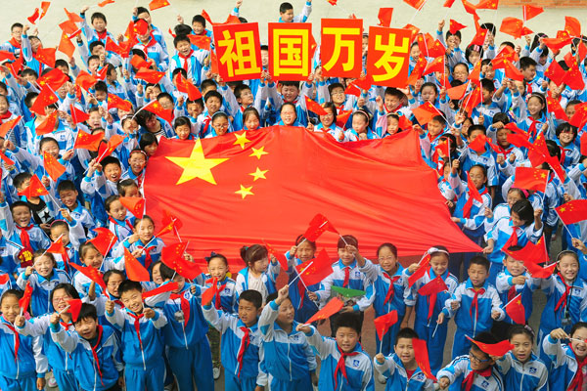
Migration | The movement of people from one place to another. | 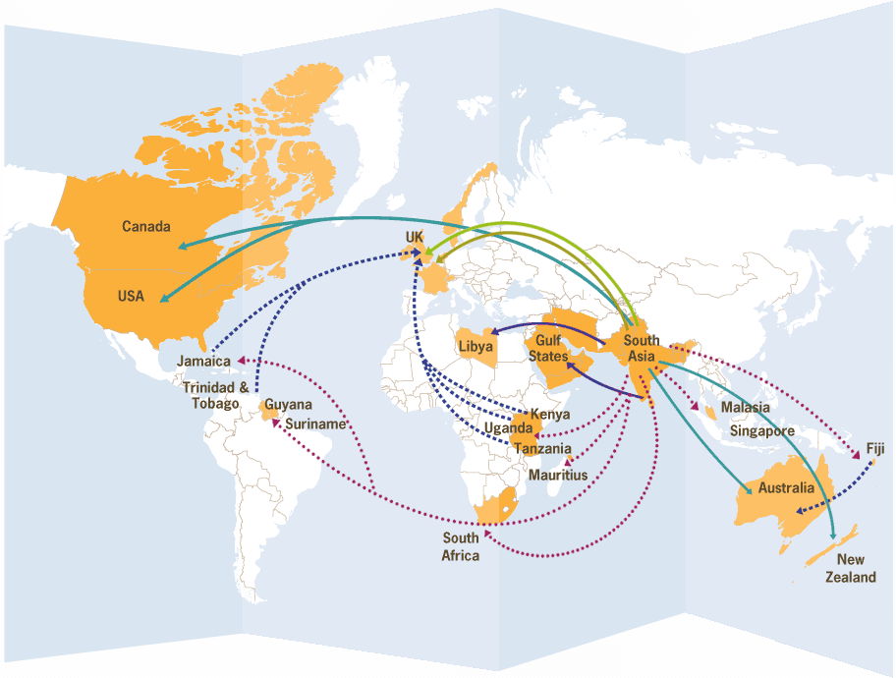
Immigration | To come into a new country and make it your new home.
Emigration | To permanently leave one’s country | 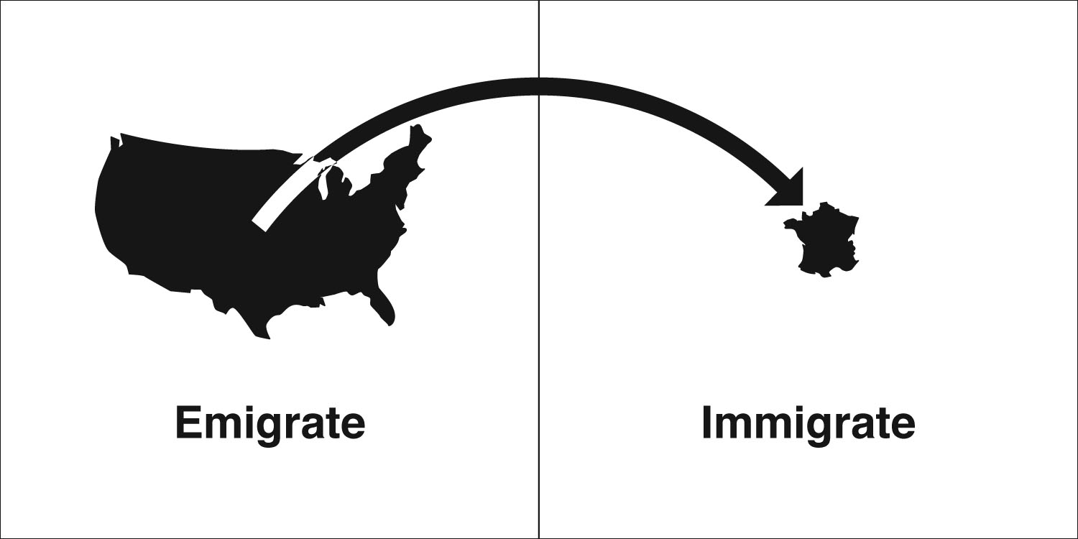
Globalization | Spreading and adopting culture. | https://www.youtube.com/watch?v=JJ0nFD19eT8
Infrastructure | Buildings, roads, energy and other man-built things needed for a society to operate.
Culture | The beliefs, traditions, art, language, and ways of life of a group of people. | 