ACT  www.actstudent.org |  |  | SAT  www.sat.org
Test Date | Deadline | Late Deadline | Test Date | Deadline | Late Deadline
September 11, 2021 | August 6, 2021 | August 20, 2021 | August 28, 2021 | July 30, 2021 | August 17, 2021
October 23, 2021 | September 17, 2021 | October 1, 2021 | October 2, 2021 | September 3, 2021 | September 21, 2021
December 11, 2021 | November 5, 2021 | November 19, 2021 | November 6, 2021 | October 8, 2021 | October 26, 2021
February 12, 2022 | January 7, 2022 | January 21, 2022 | December 4, 2021 | November 4, 2021 | November 23, 2021
April 2, 2022 | February 25, 2022 | March 11, 2022 | March 12, 2022 | February 11, 2022 | March 1, 2022
June 11, 2022 | May 6, 2022 | May 20, 2022 | May 7, 2022 | April 8, 2022 | April 26, 2022
July 16, 2022 | June 17, 2022 | June 24, 2022 | June 4, 2022 | May 5, 2022 | May 25, 2022

2021-2022
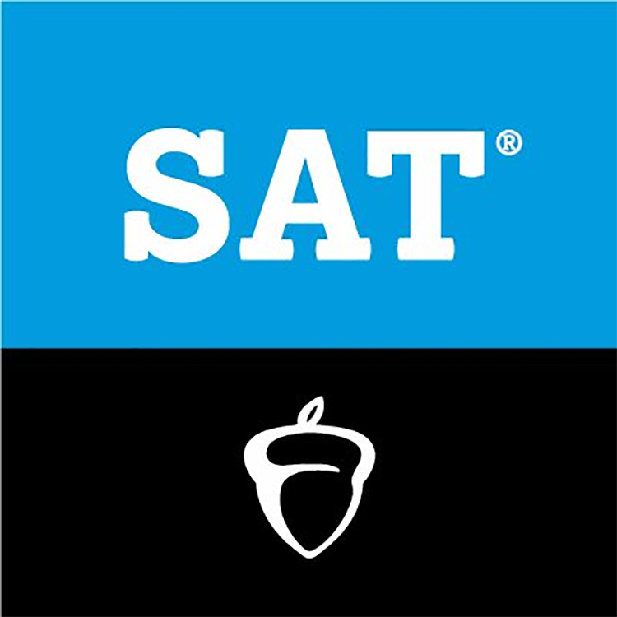
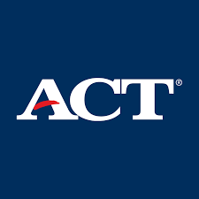
ACT and SAT Test Dates
Cotter School Code: 242720
Scan for Free SAT Test Prep
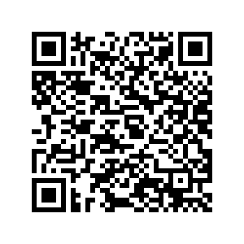
Scan for Free ACT Test Prep
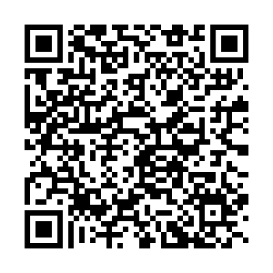

**ACT test scores are available 2-8 weeks after test. SAT test scores are available 2-4 weeks after test**
**Students register for ACT/SAT on their own. For questions contact Mrs. Klick**

