Thank you to our 2020-21 Rambler Card Sponsors. Rambler cards can be purchased for $10.
Contact the Activities Office to purchase.

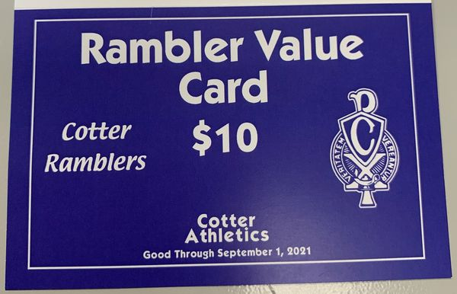

Midtown Foods
HyVee
Ground Round
Little Caesars
Unlimited Nutrition
Sammy’s
Papa Murphy’s
Nate & Ally’s
Wellington Pub & Grill
Taco John’s
Bloedow Bakery
Blooming Grounds
Acoustic Café
Dairy Queen
River City Grill
Downtown Meat Market
Rochester Wholesale Fruit

Brewski’s
Cost Cutters
Fantastic Sams
Morgan’s
McDonalds
Gordie’s
Dahl
Gerard’s Small Engine
Westgate Bowl
Cotter Schools
Benos Deli
Adventure Cycle & Ski
Whalen’s Cove
Bluff Country Coop

