Vocabulary for Paschal Mystery

Department: Religion Course: Religion 10 2016-2017

Term, Phrase, or Expression | Simple Definition | Comprehension Support
Christ | Anointed One, Messiah | Chi Rho (on all Cotter stuff)
Circle of Grace | Respect of personal space | Hula Hoop of personal space
temptation | Remember Adam and Eve. The desire to want what is inherently not good for us.
Grace | The free and undeserved gift of God’s loving and active presence in our lives, empowering us to respond to his call and to live as his adopted sons and daughters.
Image and Likeness of God | This is why humans deserve respect and grace, because only humans are created in the image and likeness of God | 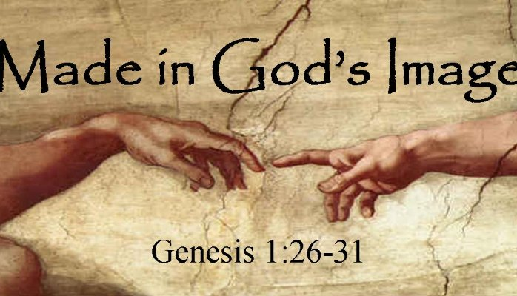
concupiscence | The tendency of all human beings toward sin, as a result of Original Sin. The human tendency to WANT to sin. Lean toward that bias. | Evil Good
Epiphany | Magi’s realization of Jesus as the Great King (also a sudden awareness or insight). | 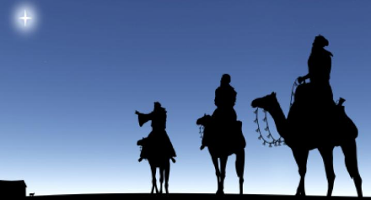
epistle | Greek for letter. Think of the New Testament letters.
foreshadow | To represent or prefigure a person before his or her life or an event before it occurs. | “Behold, the Lamb of God.” (John the Baptist about Jesus)
gospel | The “Good News” of Jesus Christ - his life, death and resurrection. 4 accounts (Mt Mk Lk Jn) 1 gospel of Jesus | 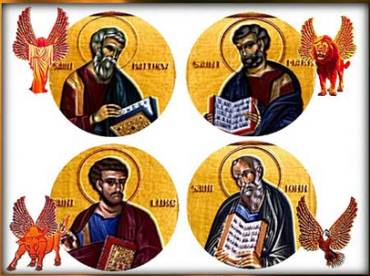
Parousia | The second coming of Christ at the end of time, fully realizing God’s plan and the glorification of humanity. Christ the King coming in glory to judge | 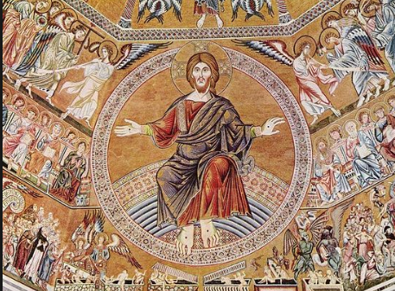
Saint  (in art depicted by a halo) | A person recognized as living a life of virtue to be emulated by the Roman Catholic Church. | 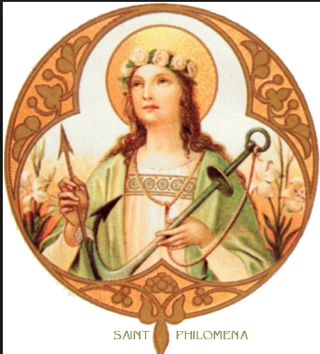
saint | All of us as a part of the Communion of saints.
Canonized  St Teresa of Calcutta (Mother Teresa) was canonized in 2016 | Process of becoming a saint. 3 miracles needed, as well as living an exemplary life.
Incarnation | From the Latin, meaning “to become flesh,” referring to the biblical Revelation that Jesus is both true God and true man. | 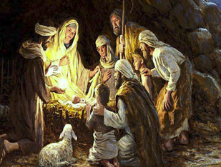
Apostle | one who is “sent forth” to preach and spread the good news. One of the original 12 chosen by Jesus. | 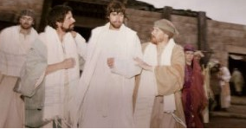
disciple | Follower (in Christianity, a follower of Jesus the Christ).
Last Supper | The night before Jesus died (sets up the Eucharist or Mass) | 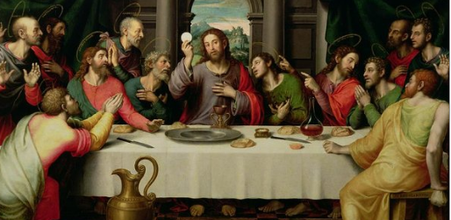
Paschal Mystery | The work of salvation accomplished by Jesus Christ mainly through his Passion, death, Resurrection, and Ascension.

